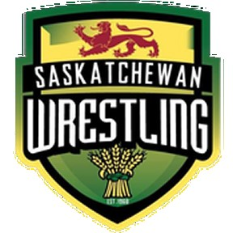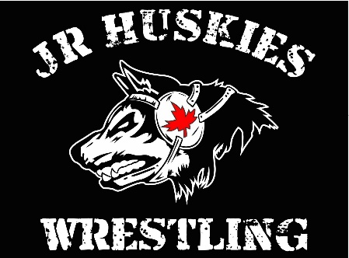

The Saskatoon Jr Huskies Wrestling Club, Inc. in conjunction with the

Saskatchewan Amateur Wrestling Association present the

U15, U17, Junior (U20), Senior, Masters - Sask. Open Provincial Championships

Saturday March 15 – St. Joseph High School – 115 Nelson Road, Saskatoon

**Entry Fee:** $30 per event - A Registration Link will be sent to all Clubs when registration opens

**Schedule:**

8:30 am - Gym Opens

9:00 a.m. – 9:30 a.m. - Weigh-ins for U 15, U17, Junior, Masters

10:30 a.m. – U15, U17, Junior, Masters Competition commences until completion

12:00 – 12:30 p.m. - Weigh ins for U19 and Senior

1:30 p.m. – U19, Senior Competition commences until completion

**Age Groups and Weight classes**

MEN’S MASTERS – Class A (1991 – 2000), Class B (1983 – 1990), Class C (1975 – 1982), Class D (1967 – 1974), Class E (1959 – 1966), Class F (1950 – 1958)

Men – 58, 62, 70, 78, 88, 100, 100 – 130 kg

Women – will be pooled according to weight

SENIOR: 20 + years of age (born in 2004 and older). Any athlete over 40 years old must provide a medical certificate that states that they are physically able to compete.

WOMEN (WW): 50, 53, 55, 57, 59, 62, 65, 68, 72, 72 - 76 kg

MEN’S FREESTYLE (FS): 57, 61, 65, 70, 74, 79, 86, 92, 97, 97 - 125 kg

U20-JUNIOR: 18 to 20 years of age (born in 2005, 2006, 2007) Athletes from 17 years of age (born 2008 and older) may compete in Junior competition, however parental authorization and a medical certificate are required.

WOMEN (WW): 50, 53, 55, 57, 59, 62, 65, 68, 72, 72 - 76

MEN’S FREESTYLE (FS): 57, 61, 65, 70, 74, 79, 86, 92, 97, 97 - 125 kg

U19: 17-18 years of age (born in 2007, 2008)

WOMEN (WW): 36-40, 43, 46, 49, 53, 57, 61, 65, 69, 73, 80, 80 - 90 kg

MEN’S FREESTYLE (FS): 39-42, 45, 48, 51, 55, 60, 65, 71, 80, 92, 110, 110 - 125 kg

U17: 15-16 years of age (born in 2009, 2010)

WOMEN (WW): 36-40, 43, 46, 49, 53, 57, 61, 65, 69, 73, 80, 80 - 90 kg

MEN’S FREESTYLE (FS): 39-42, 45, 48, 51, 55, 60, 65, 71, 80, 92, 110, 110125 kg

U15: 13-14 years of age (born in 2011, 2012)

WOMEN (WW): 33, 36, 39, 42, 46, 50, 54, 58, 62, 66, 70, 80 kg

MEN’S FREESTYLE (FS): 34, 38, 41, 44, 48, 52, 57, 62, 68, 75, 85, 100 kg

**Rules:** Competition rules will be in accordance with the most recent WCL Rulebook including any UWW Modifications. Athletes may wear a red/blue singlet in accordance with WCL rules or a team/club singlet.

**Medical Services:** Event Medical Personnel will be in attendance. Any athletes who require preventative therapy is required to bring their own supplies.

**Eligibility:** All participating athletes, coaches and officials must be members in good standing with Saskatchewan Amateur Wrestling Association or their Prov. association

**Medal Presentations**: Medals will be presented at the end of each competitive section outlined above.